Static Website Deployment from S3

Step 1 | Open Amazon S3 Console

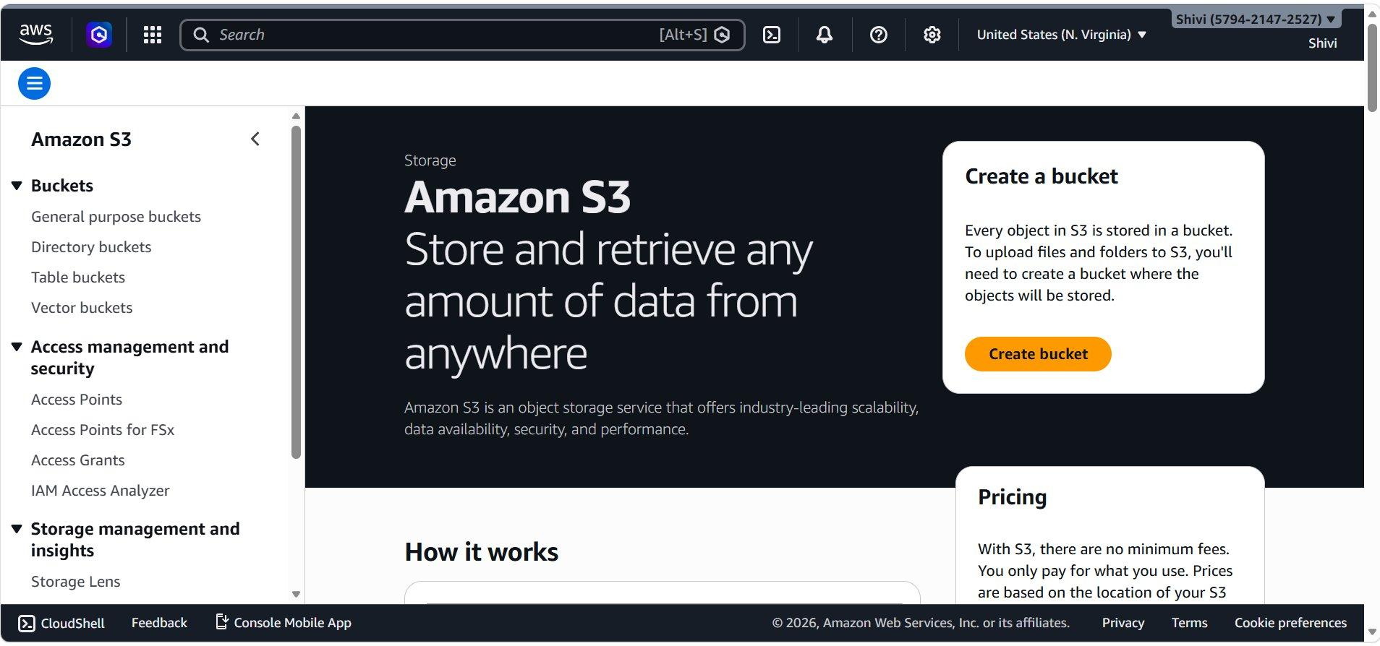
- Log in to your AWS Management Console
- In the top search bar, type S3 and select Amazon S3 from the dropdown. You will land to S3 homepage.
- Click the orange Create bucket button on the right panel to begin.

Step 2 | Configure Bucket Name & Type

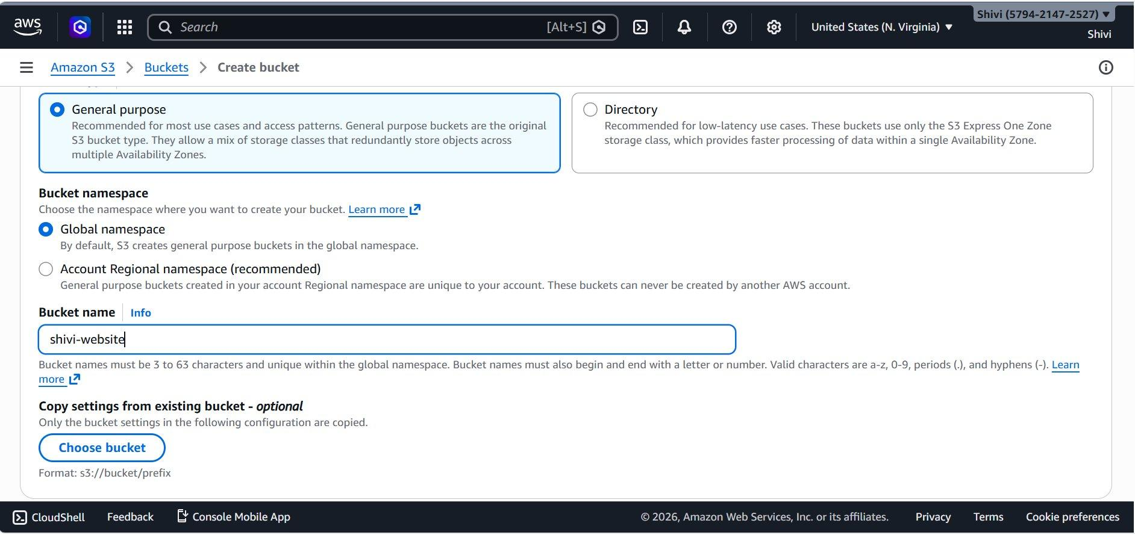
On the Create bucket page, configure the basic settings for your new bucket as shown below.
- Select General purpose as the bucket type
- Under Bucket namespace, keep Global namespace selected (default).
- Enter a unique Bucket name — here it is shivi-website.
- Names must be 3–63 characters, globally unique, and use only lowercase letters, numbers, periods (.), and hyphens (-).

Step 3 | Enable ACLs & Set Object Ownership

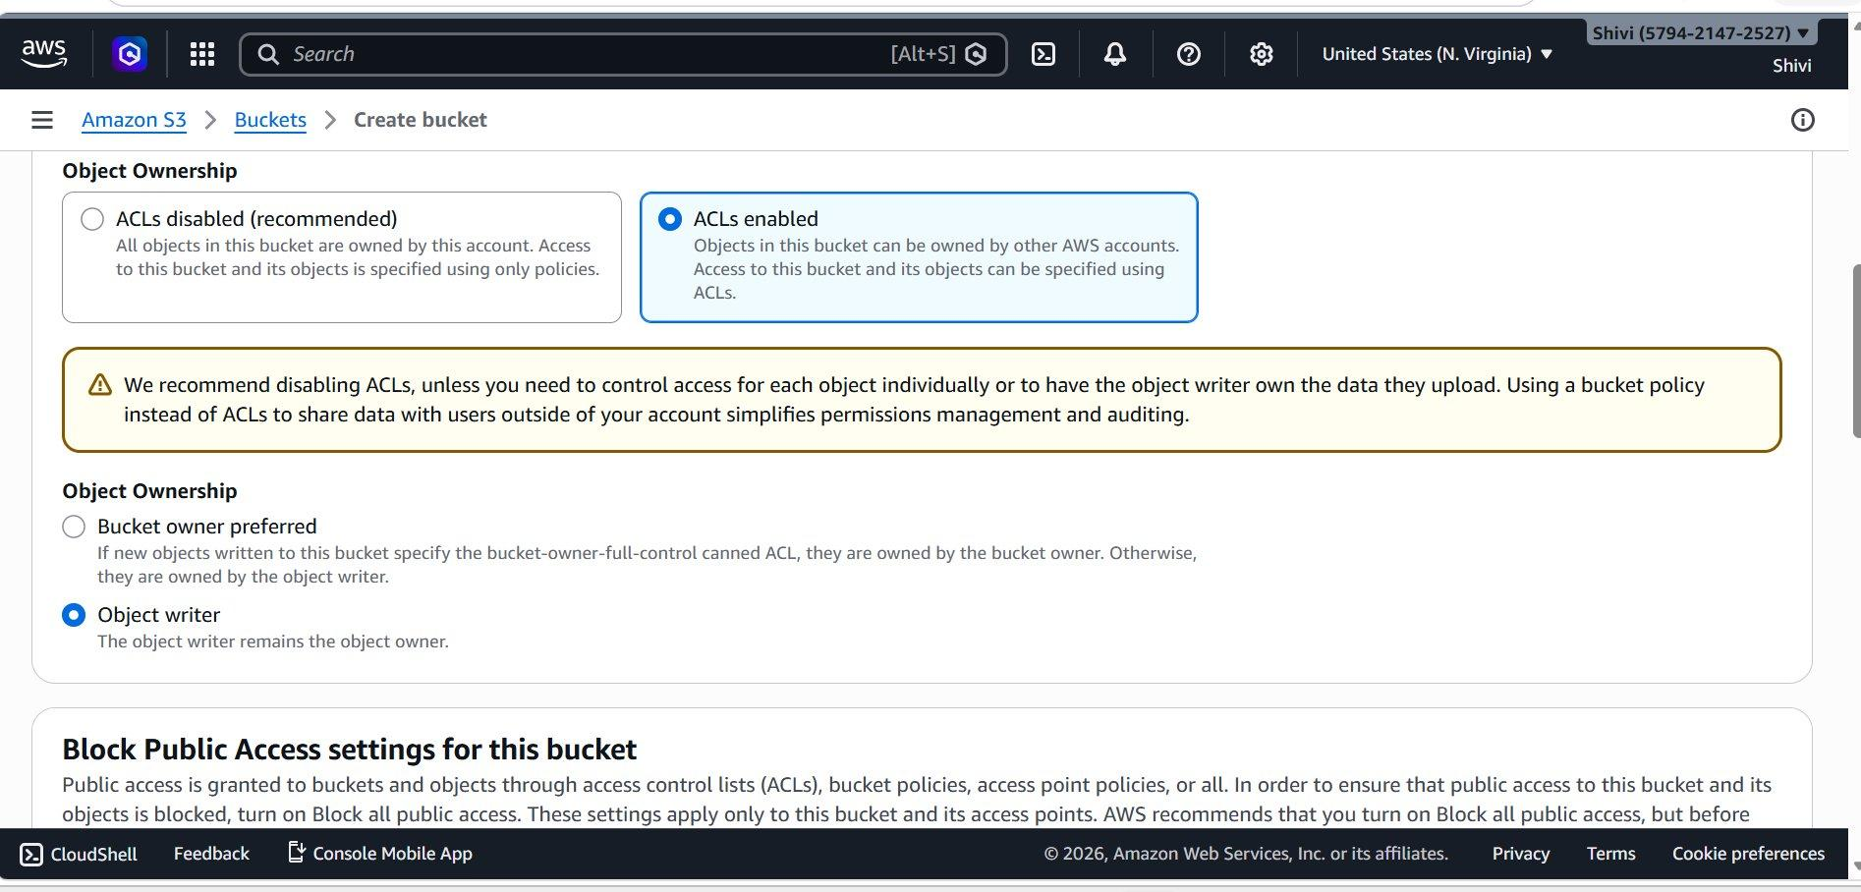
Scroll down to the Object Ownership section. Here you decide who owns objects uploaded to this bucket.
- Select ACLs enabled — this allows objects to be owned by other AWS accounts and access to be controlled via ACLs.
- Under Object Ownership sub-options, select Object writer — the uploader remains the owner of objects they upload.
- This is necessary so you can later make individual files public using the ACL.

Step 4 | Disable Block Public Access

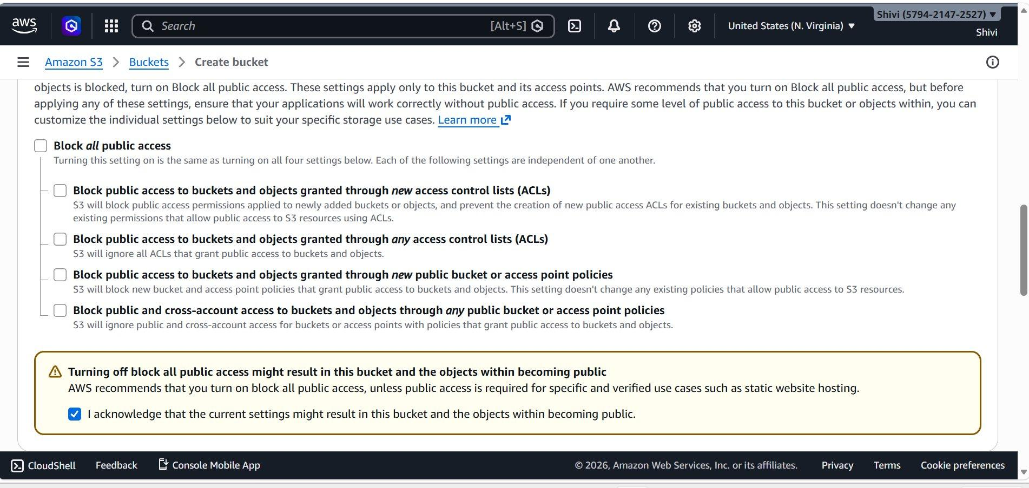
Scroll to Block Public Access settings for this bucket. By default, all public access is blocked. For a static website, you must disable this.
- Uncheck Block all public access to allow public internet access to the bucket and its objects.
- Check the acknowledgment box: 'I acknowledge that the current settings might result in this bucket and the objects within becoming public.'
- This is required so your website visitors can access your HTML, CSS, and image files.

Step 5 | Set Default Encryption & Create Bucket

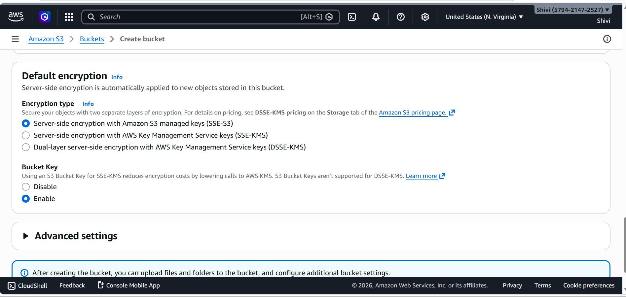
Scroll to the Default encryption section. Encryption is automatically applied to all new objects stored in this bucket.

Step 6 | Upload Your Website Files

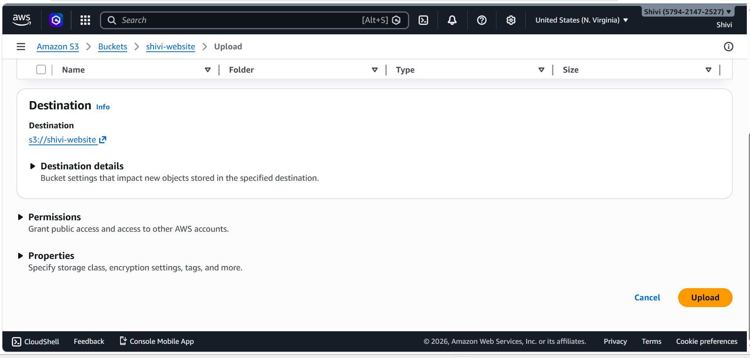
Click on your newly created bucket (shivi-website) and then click Upload. The upload page is shown below.
- Add your website files by clicking Add files or dragging them into the upload area.
- Click the orange Upload button to upload your files.

Step 7 | Open the Uploaded File (index.html)

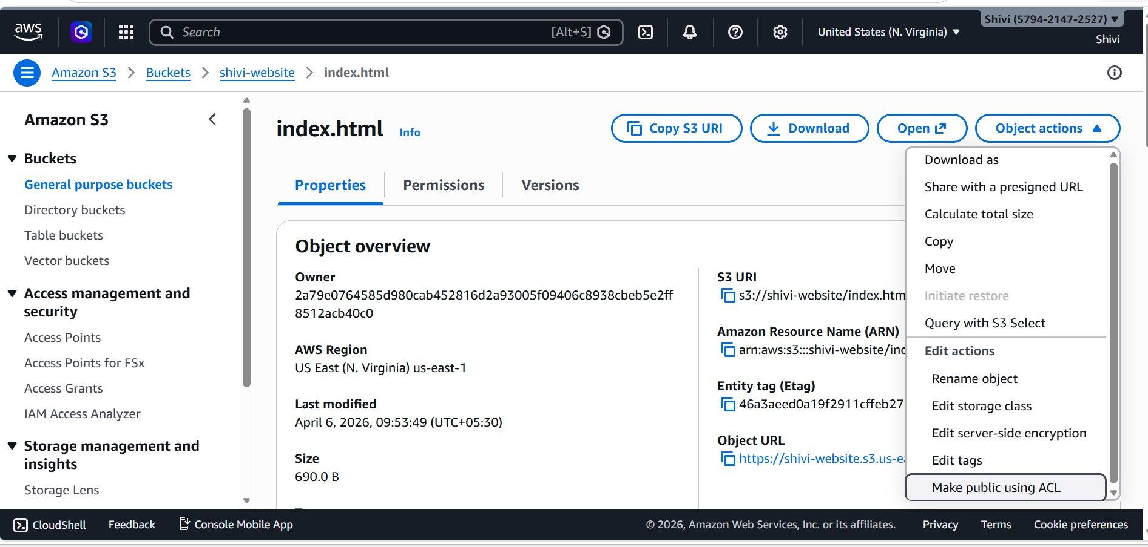
Once uploaded, click on index.html in the bucket to open its object detail page as shown below.
- The S3 URI is: s3://shivi-website/index.html
- The Object URL is the public HTTP URL once the file is made public.
- Click the Object actions dropdown in the top-right corner.
- From the dropdown menu, scroll down and select Make public using ACL.

Step 8 | Confirm: Make Public Using ACL

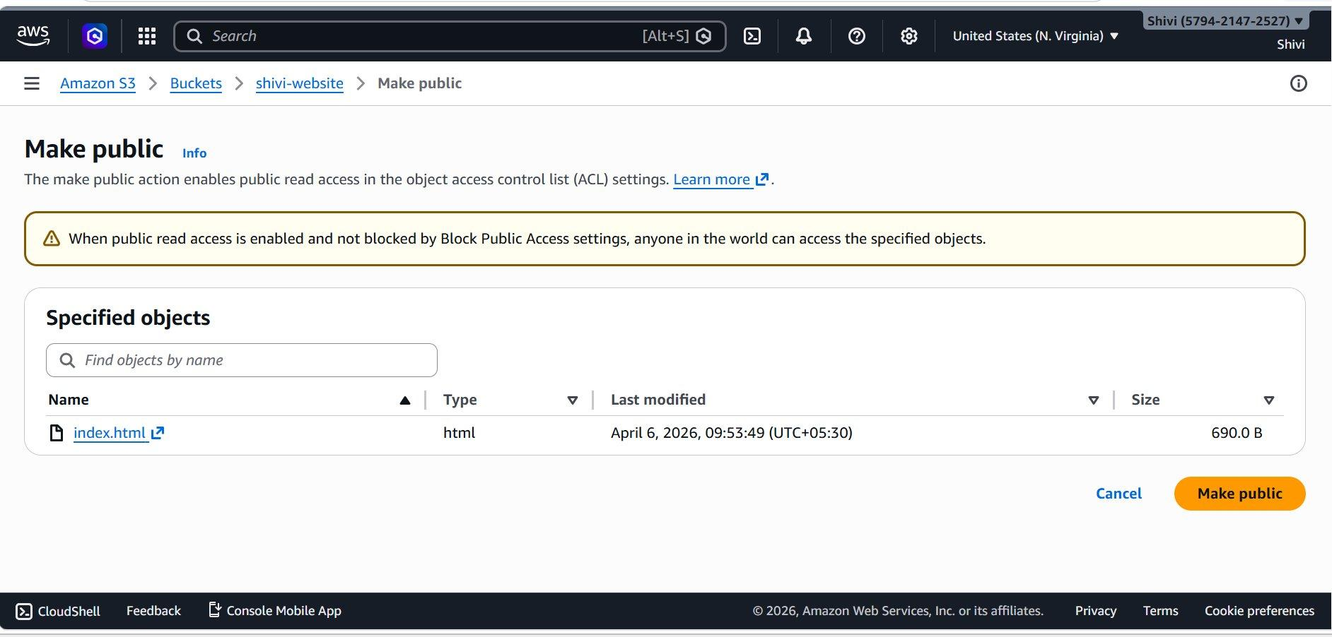
After clicking Make public using ACL, a confirmation page appears listing the objects that will be made publicly readable.
- Review the listed objects carefully to ensure you are making the correct files public.
- Click the orange Make public button to apply public read access to the listed objects via ACL.

Step 9 | Verify: Public Access Successfully Applied

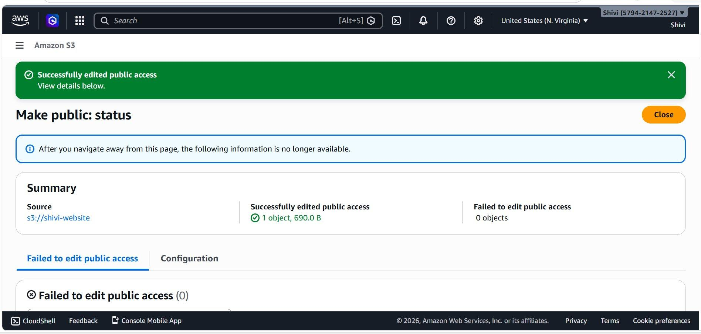
After clicking Make public, you will see the Make public: status page confirming the result.
- A green success banner reads: 'Successfully edited public access — View details below.'

